Today I went to visit my friend Jeremy at his house. We had a full day planned of shopping with the intent of going to dinner later in the afternoon. I arrived at Jeremy’s house to hear him and his father arguing over politics. It was clear that they were of two opposing positions but Jeremy seemed more passionate about the subject and it was getting a little heated. Upon noticing my arrival, Jeremy’s father attempted to table the argument for another time but Jeremey was insistent on continuing the debate. After a few more minutes Jeremey had made his point and we left to go shopping.

At the local Target, Jeremey had a package to return. This was returned without incident and we continued to shop for most of the rest of the day. We ended the night by going out to eat for dinner. It had been a long day and so we were both rather hungry. Jeremey and I ordered our meals. However, Jeremey’s steak came out more cooked than he had initially ordered. I recalled the steak being ordered to be medium but it came out well done. Jeremey called his server over and the server insisted that Jeremey had wanted the steak to be well done. They argued over it for a minute after which Jeremey asked to talk to a manager. The manager showed up shortly thereafter and after a charged back and forth, the manager agreed to discount the meal due to the error of the server and grill staff. We left the restaurant full and proceeded back to Jeremey’s house. After arrival, I wished him goodbye and goodnight.

(please realize participants will receive one of the pictures below)



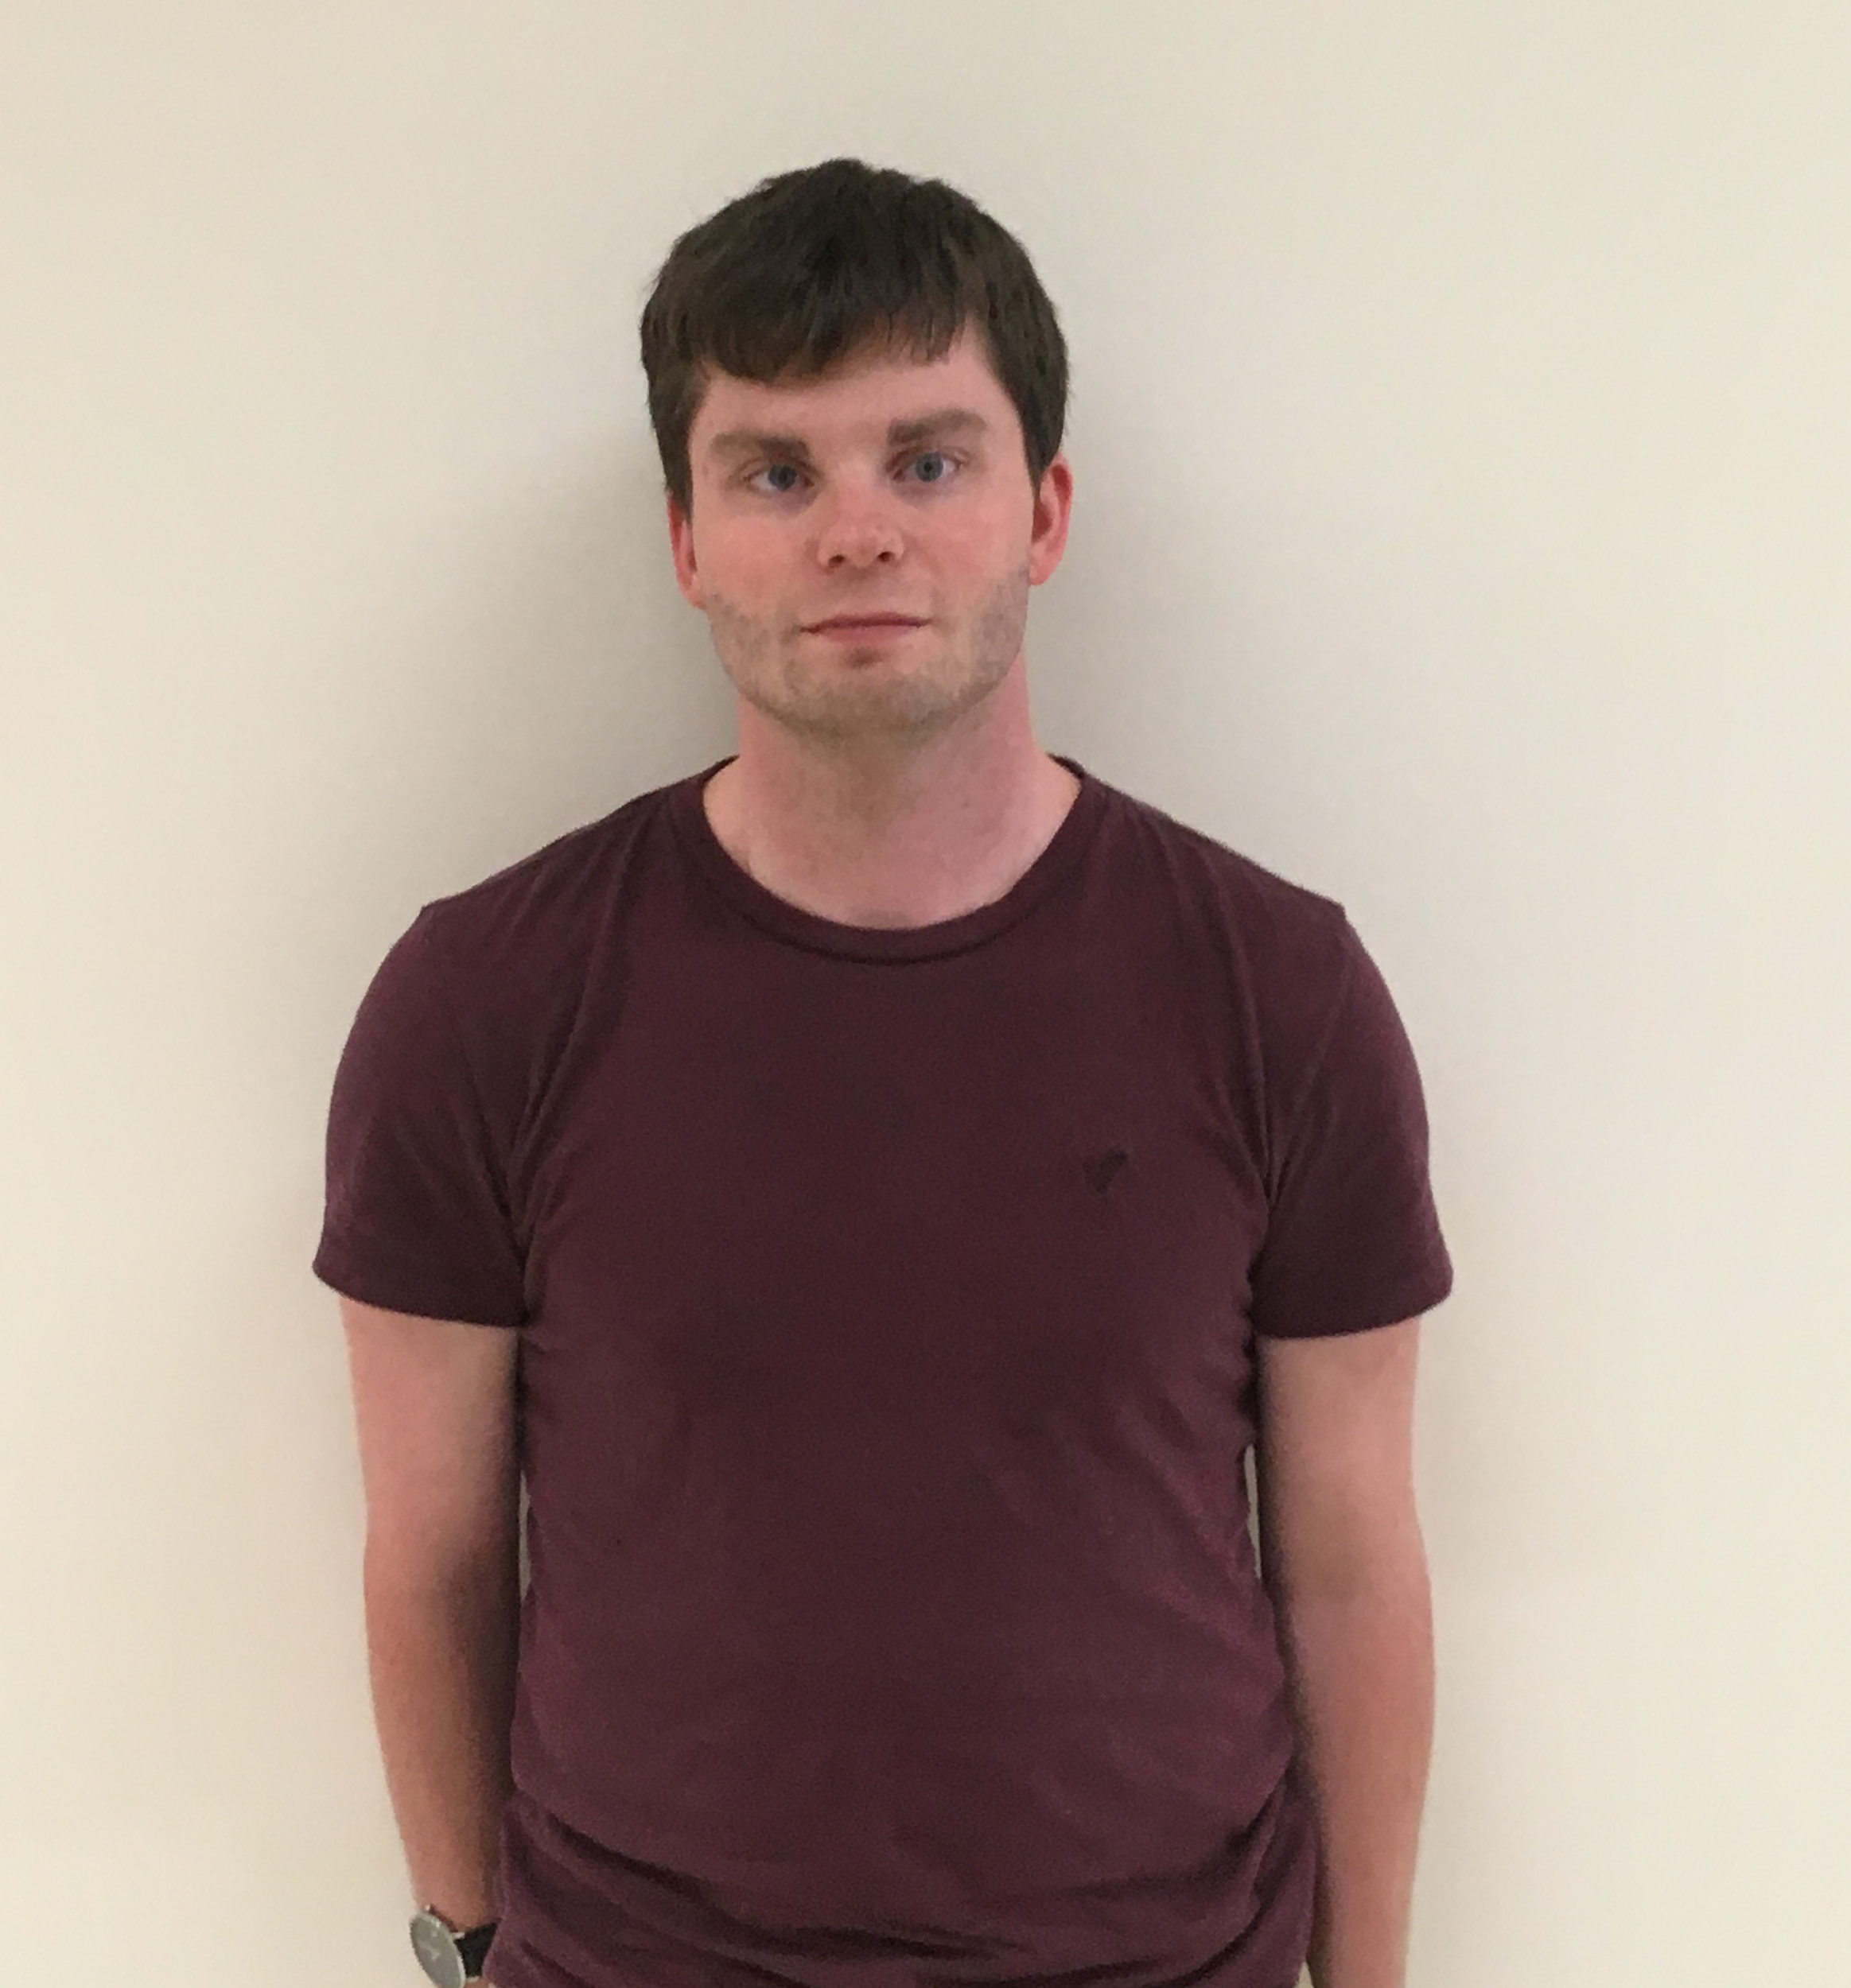

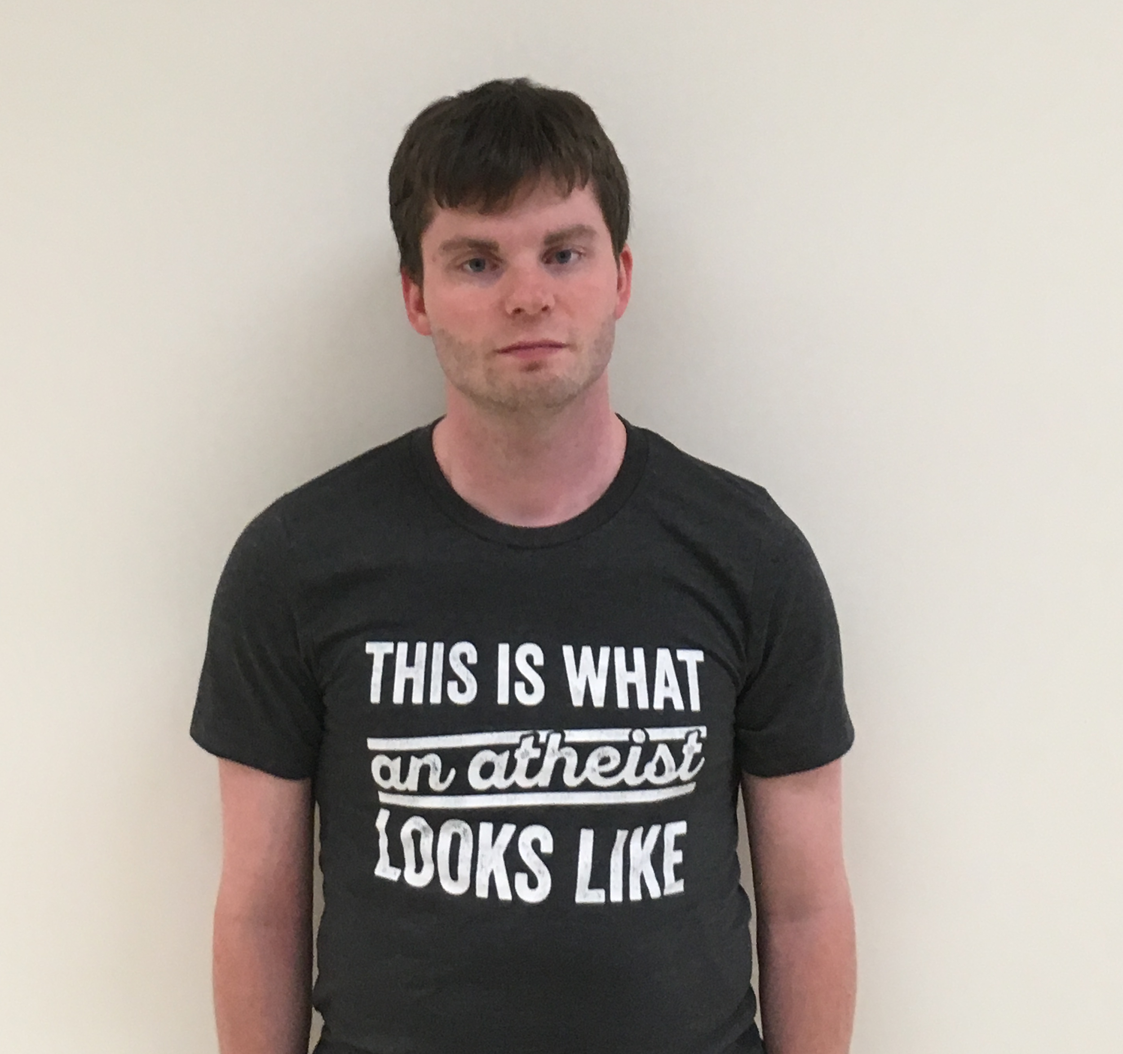

Trait assessments of target

For each of the items below, please indicate how strongly this characteristic is expressed by the person you had read about in the brief description. Please use the scale provided.

0 1 2 3 4 5 6 7 8 9 10

Not at all Completely

Expressed Expressed

_____. 1. Hostile

_____. 2. Aggressive

_____. 3.Combative

_____. 4. Short-tempered

_____. 5.Selfish

_____. 6.Friendly

_____. 7.Mild

_____. 8.Accommodating

_____. 9. Patient

_____. 10.Giving

Now think back to the description of that individual. Please form a mental image of what you think this person is like and how they interact with others. Imagine also you met with this person. Please indicate your expectation that you would be willinging to do each of the following actions using the scale provided.

1 2 3 4 5

Not at all Willing Extremely Willing

1. Say hello.______
2. Shake their hand. ______
3. Sit next to them in class. ______
4. Help the other person out on some minor detail (e.g., loan them a pencil). ______
5. Walk away from the person if you saw them. ______
6. Ostracize the other person in some way. ______
7. Talk badly about them. ______
8. Refuse to help them. ______

Scale Items

Please indicate the extent to which you feel positive or negative towards each issue. Scores of 0 indicate greater negativity and scores of 100 indicate greater positivity. Scores of 50 indicate you feel neutral about the issue. (Everett, 2013)

1. Abortion ______
2. Religion______
3. Traditional Marriage______
4. Traditional Values______
5. The Family Unit______

Please rate your level of agreement or disagree with each of the following statements from 1 to 5 (1-Strongly Disagree, 2-Disagree, 3-Uncertain, 4-Agree, 5-Strongly Agree) (Francis et al, 2016)

1. ______While I believe in the Christian faith, there are more important things in my life
2. ______While I am a Christian, I do not let my faith influence my daily life
3. ______Occasionally I have compromised my Christian beliefs to fit in better with my friends
4. ______One reason for me going to church is to connect with others my own age
5. ______A key reason for my interest in church is that it is socially enjoyable
6. ______I go to church because it helps me feel part of a community
7. ______One reason for me praying is that it helps me to gain relief and protection
8. ______What prayer offers me most is comfort when bad things happen to me
9. ______I pray mainly because it makes me feel better
10. ______My Christian faith shapes how I live my daily life
11. ______I try hard to carry my Christian faith over into all other areas of my life
12. ______My Christian faith really shapes the way I treat people
13. ______I allow almost nothing to prevent me from going to church on Sundays
14. ______I go to church because it helps me feel close to god
15. ______The church is the most important to me as a place to be part of Christ’s family
16. ______I pray at home because it helps me be aware of God’s presence
17. ______I often read books about prayer and the spiritual life
18. ______I pray mainly because it deepens my relationships with God

Please respond to each of the statements below. Please realize there are no correct or incorrect responses. For each item, please indicate your agreement or disagreement with the item by using the specific numeric value from the scale below.

1 2 3 4 5 6 7 8 9

Very Strongly Feel Neutral Very Strongly

Disagree Agree

1. ______The established authorities generally turn out to be right about things, while the radicals and protestors are usually just "loud mouths" showing off their ignorance.
2. ______Women should have to promise to obey their husbands when they get married.
3. ______ Our country desperately needs a mighty leader who will do what has to be done to destroy the radical new ways and sinfulness that are ruining us.
4. ______ Gays and lesbians are just as healthy and moral as anybody else.
5. ______ It is always better to trust the judgement of the proper authorities in government and religion than to listen to the noisy rabble-rousers in our society who are trying to create doubt in people's minds.
6. ______ Atheists and others who have rebelled against the established religions are no doubt every bit as good and virtuous as those who attend church regularly.
7. ______ The only way our country can get through the crisis ahead is to get back to our traditional values, put some tough leaders in power, and silence the troublemakers spreading bad ideas.
8. ______There is absolutely nothing wrong with nudist camps.
9. ______Our country needs free thinkers who have the courage to defy traditional ways, even if this upsets many people.
10. ______Our country will be destroyed someday if we do not smash the perversions eating away at our moral fiber and traditional beliefs.
11. ______ Everyone should have their own lifestyle, religious beliefs, and sexual preferences, even if it makes them different from everyone else.
12. ______The "old-fashioned ways" and the "old-fashioned values" still show the best way to live.
13. ______You have to admire those who challenged the law and the majority's view by protesting for women's abortion rights, for animal rights, or to abolish school prayer.
14. ______ What our country really needs is a strong, determined leader who will crush evil, and take us back to our true path.
15. ______Some of the best people in our country are those who are challenging our government, criticizing religion, and ignoring the "normal way things are supposed to be done."
16. ______ God's laws about abortion, pornography and marriage must be strictly followed before it is too late, and those who break them must be strongly punished.
17. ______ There are many radical, immoral people in our country today, who are trying to ruin it for their own godless purposes, whom the authorities should put out of action.
18. ______ A "woman's place" should be wherever she wants to be. The days when women are submissive to their husbands and social conventions belong strictly in the past.
19. ______Our country will be great if we honor the ways of our forefathers, do what the authorities tell us to do, and get rid of the "rotten apples" who are ruining everything.
20. ______There is no "one right way" to live life; everybody has to create their own way.
21. ______Homosexuals and feminists should be praised for being brave enough to defy "traditional family values."
22. ______This country would work a lot better if certain groups of troublemakers would just shut up and accept their group's traditional place in society.

Please rate your level of agreement or disagree with each of the following statements from 1 to 7 (1-Disagree Strongly, 2-Disagree Moderately, 3-Disagree A Little, 4-Neither Agree or Disagree, 5-Agree A Little, 6- Agree Moderately, 7-Agree Strongly) (Gosling, Rentfrow & Swan, 2003)

I see myself as….

1. ______Extraverted, enthusiastic
2. ______Critical
3. ______Dependable
4. ______Anxious, Easily Upset
5. ______Open to New Experiences, Complex
6. ______Reserved, Quiet
7. ______Sympathetic, Warm
8. ______Disorganized, Careless
9. ______Calm, Emotionally Stable
10. ______Conventional, Uncreative

Post study survey

Please take a few moments and answer each of the questions to the best of your ability.

1. In the person description you saw earlier, what ethnicity and gender was the person you saw? ______________________________________________
2. What color was their shirt? ______________________
3. What was printed on the person’s shirt (do your best to describe it, you need not mention every detail, just a general description)? ______________________________________________________________________

Debriefing Form

Thank you for participating in this study!  We hope you enjoyed the experience. This form provides background about our research to help you learn more about why we are doing this study. Please feel free to ask any questions or to comment on any aspect of the study.

At the beginning of this study, you were informed that purpose of this study was to examine how easily people can assess another person's traits via a brief biographical description and picture of the person and how these assessments might impact subsequent social interactions. You were randomly assigned to one of three groups. As a participant you were exposed to a visual depiction of a person who was Christian, Atheist or Neutral based on the content of the shirts they were wearing and asked to read a scenario involving that person. You were then asked to answer several follow up questions that assessed a wide range of topics.

As you may know, some studies use deception in situations where there is no other way to conduct the experiment without a level of bias. We are very sorry to say that the current study did involve deception. Unfortunately, it was necessary to use deception because, had participants know the true nature of the study, responses would have been likely to change.

The actual purpose of this study is to investigate the influence of religiosity and atheism on whether or not these affiliations will bias an individual’s judgments of people who belong to either different or similar affiliations as well as their willingness to help others based upon group affiliation. We hope to see that individuals rate people belonging to their same religious affiliation in a more positive light than they do individuals who do not belong to their same religious affiliation. This research would extend work on in and out group dynamics to include religiosity. Applications might include furthering ways to mitigate those in and out group biases within the domain of religion. For cultures that are continually becoming more diverse this would be an important endeavor.

In this study, we asked for you to identify your religious affiliation. You were then visually presented, at random, with a person wearing an atheist themed T-shirt, Christian themed T-shirt or neutral T-shirt and asked to read a description involving that hypothetical person. The scenarios for each visual presentation were exactly the same. The only difference in the three conditions was what T-shirt was being worn by the visual presentation. After seeing the visual presentation and reading the scenario involving that hypothetical person, all participants were asked the same questions in the same order.

The data from this study will be presented in groups in research journals, however we want to assure you that no identifying information will be used. All data will be kept secure, only to be analyzed by trained researchers. Nonetheless, if you feel uncomfortable with this study, your participation in this is still voluntary. If you wish, you may withdraw after reading this debriefing form, at which point all records of your participation will be destroyed. You will not be penalized if you withdraw. You can also feel free to contact the investigator with any further questions.

Investigator                               Contact Number                              Email

Brier Gallihugh (989)-423-6118 bgallihu@emich.edu

Rusty McIntyre                          (734)536-4105     [rmcinty4@emich.edu](mailto:rmcinty4@emich.edu)

If you want more information about your rights as a participant or want to report a research-related harm, you may contact the Institutional Review Board at (734) 487-3090.